高二英语答案

1--5 CBCBA 6--10 BABAA 11-15 CBCBA 16--20 CBACC

21--23.CDA24. C 25. D 26. B 27. A28. D 29. B学科网(www.zxxk.com)--教育资源门户，提供试卷、教案、课件、论文、素材及各类教学资源下载，还有大量而丰富的教学相关资讯！ 30. A 31. C32. B33. D34. C 35. A36. B 37. A 38. D 39. G 40. F

41-45 BCADC 46-50 ADBAB 51-55 CDDCB 56-60 ABADC

**6**1. (should) go

62. and

63. infection

64. planned

65. that

66. an

67. creating

68. potentially

69. for

70.be canceled/ cancelled

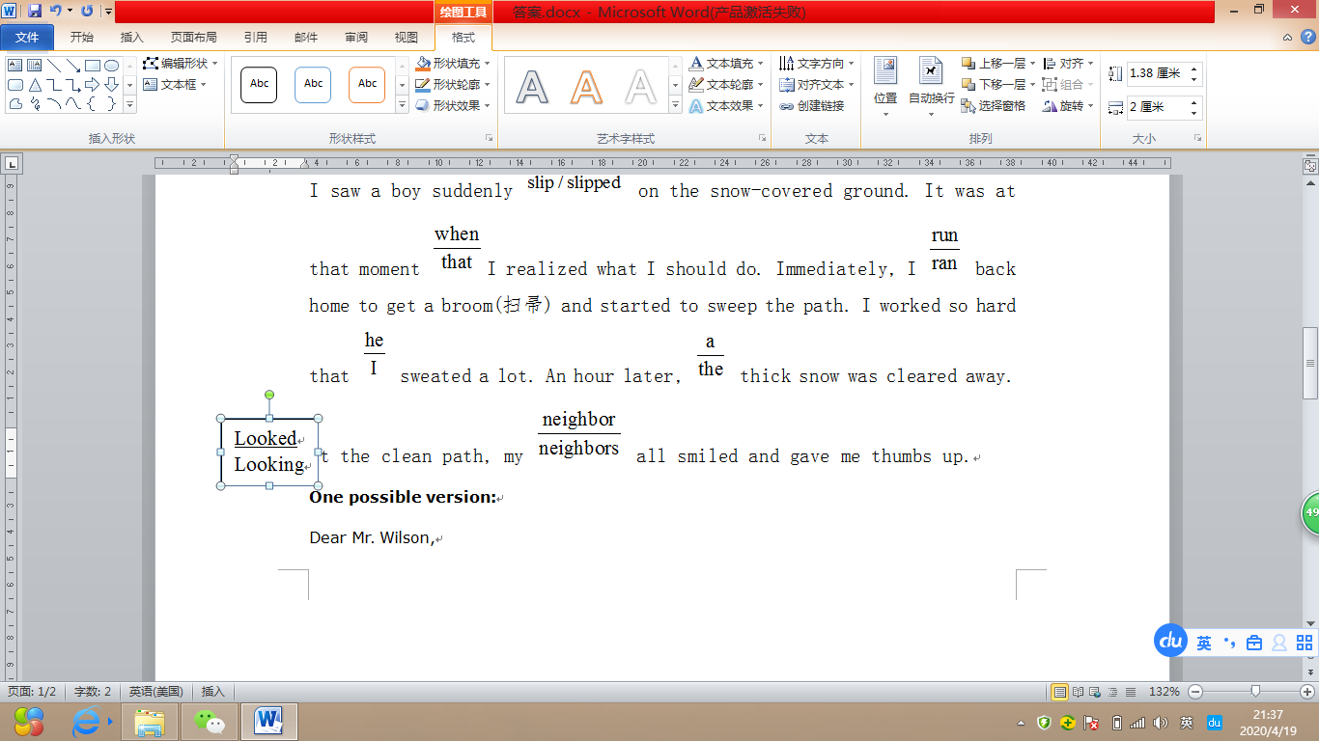This morning, when I looked out the window, I excitedly found it was snowing . Attracted by the beautiful sight, I decided to go out to take some photos. As I walked on the path in front of our building, I saw a boy suddenly  on the snow-covered ground. It was at that moment I realized what I should do. Immediately, I  back home to get a broom(扫帚) and started to sweep the path. I worked so hard that  sweated a lot. An hour later,  thick snow was cleared away. at the clean path, my  all smiled and gave me thumbs up.

**One possible version:**

Dear Mr. Wilson,

How is everything going? I’ve been back home now. I’m writing to express my sincere gratitude to you for your kindness.

While I was in England, your help and kindness made my stay special and enjoyable. How I miss the days we spent together! Thanks to your help, I got used to the lifestyle there soon. I still miss the delicious meals you prepared for me. Besides, I really appreciate your patience while talking to me. By practicing speaking with you every day, I gradually improve my spoken English.